RIDER – Covid-19 emergency – English

To avoid possible infection with the virus, we give you some tips to protect yourself and others. Follow carefully these simple security measures.

- When you start work:
Wear the mask, which is always compulsory, with the following precautions:
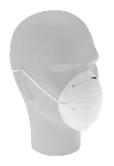
- Wash your hands thoroughly, with soap and water or with an alcohol-based disinfectant, before putting it on;
- Make sure that the correct side of the mask, usually white in the coloured ones, faces inwards;
- Make the mask adhere well to the face and tighten the rigid upper edge around the nose and make sure that it covers the nose and mouth and that the lower edge is under the chin;
- Avoid, as much as you can, touching the mask and the face during work.

Wear gloves when necessary
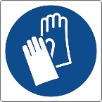
The use of disposable gloves is required in cases of contact with surfaces that could be contaminated such as, for example, the door and lift handles, shopping trolleys or support surfaces. If you have no gloves, pass alcoholic gel over your hands after touching those surfaces.

- While you are working:
Always keep your distance, which is the best precaution to avoid infection.
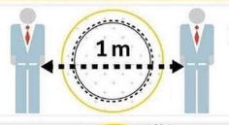
- When you collect and deliver the goods, always keep a distance of at least one metre from people.
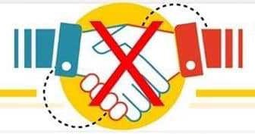
- If you are paid cash, put the money in a plastic bag. At the end of the shift, disinfect the bag with the sanitizing gel using gloves.
- Even during breaks, in waiting times, when you are with colleagues always keep a distance of at least one metre and always greet them at a distance without shaking hands.

- When you finish work:
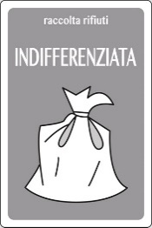
- Remove the mask grabbing it by the elastics or laces; do not touch the filtering part.
- Remove the gloves; they must be removed inside out.
- Put the mask and gloves in a plastic bag and throw them in the non-recyclable waste container. Do not reuse them.
- Clean your bicycle's bag, mobile phone, POS and handlebar with the sanitizing gel and then wash your hands thoroughly.

Realized by the Municipality of Milan in collaboration with the CCP Center for the culture of prevention in the workplace and life

